Logistic Regression
From Linear Regression to Pharmacy Analytics: Predicting High-Cost Prescribers in Medicare Part D

Summary
- Audience: you understand linear regression — fitting y = b0 + b1x1 + … + bnxn to predict a number — but have never used logistic regression.
- The idea in one sentence: logistic regression is linear regression whose output is squashed through the sigmoid function, so it predicts a probability between 0 and 1 instead of an unbounded number. The difference in one more: linear regression answers “how much?” — predicting a continuous number by fitting a line that minimizes squared error — while logistic regression answers “which one?” — predicting the probability of a category by fitting the same linear combination on the log(odds) scale to minimize log-loss.
- The case study: using real CMS Medicare Part D data, predict whether a prescriber lands in the top 25% of drug cost per claim — without letting the model see cost. Result: 84.8% accuracy against a 74.9% do-nothing baseline, ROC AUC 0.879.
- Part 2 — interpretation: the model's coefficients are changes in log(odds); exponentiating them gives odds ratios. A one-standard-deviation increase in brand share multiplies the odds of being high-cost by about 5.1.
- Part 3 — inference: transforming the y-axis to log(odds) turns the S-curve into a straight fitted line; Wald's test (z = coefficient / standard error) supplies p-values and confidence intervals — brand share: z = 11.8, odds-ratio 95% CI [3.97×, 6.88×].
- Everything here is reproducible: the notebook “40 logistic_regression_pharmacy.ipynb” contains every graph in this document with the code that made it.

1. Why a Straight Line Fails for Yes/No Outcomes
In linear regression the outcome is a number, and the fitted line may sensibly predict any value. Our outcome is a category — a prescriber is high-cost (1) or typical (0). Fit a straight line anyway, and it immediately predicts 'probabilities' above 1 and below 0:
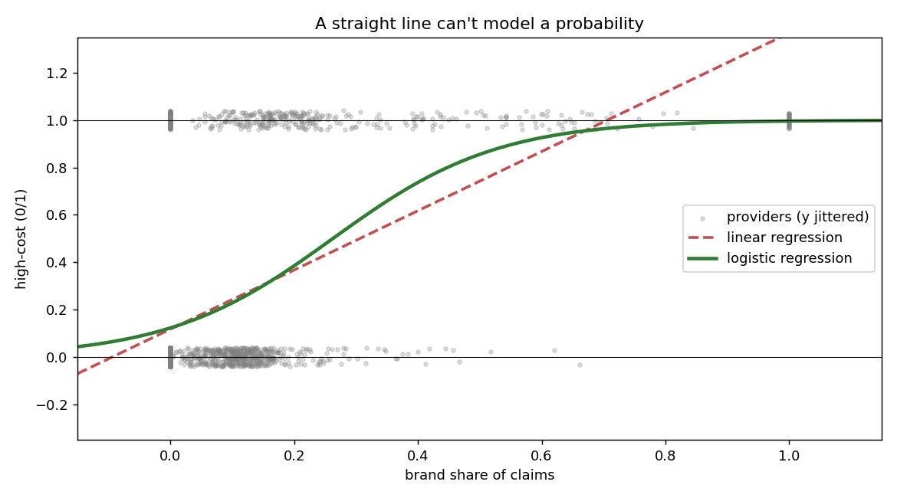
Figure 1. A straight line (dashed) leaves the valid probability range; the logistic curve (solid) never does.
The dashed line is the linear regression you already know. The green curve is logistic regression fit to the same single feature — it uses the same linear machinery internally but its output always stays between 0 and 1.

2. The Sigmoid: One Function Fixes It
Keep the familiar linear combination z = b0 + b1x1 + … + bnxn, but pass it through the sigmoid to get a probability: p = 1 / (1 + e^(−z)).
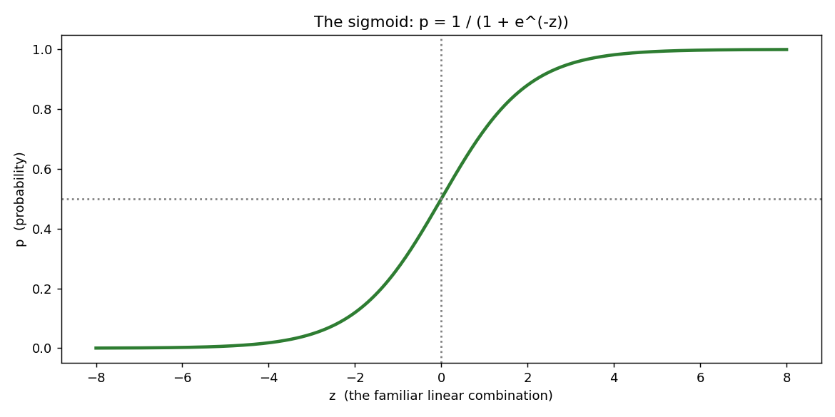
Figure 2. The sigmoid squashes any z into (0, 1); z = 0 maps to p = 0.5, the default decision boundary.
- Large positive z → p near 1 (confident 'high-cost').
- Large negative z → p near 0 (confident 'typical').
- Decision rule: predict class 1 when p ≥ 0.5 — a threshold you may tune to your error costs.
- Training: the weights are chosen to minimize log-loss, which heavily penalizes confident wrong answers.

3. The Case Study: CMS Medicare Part D Data
The dataset is real: one row per prescribing provider, with claims counts, drug cost, brand/generic mix, and patient panel characteristics. There is no data file to manage — the code downloads it live from data.cms.gov each time it runs, controlled by a single setting called DATA_ROWS. Give it an integer and it pages that many providers from the JSON API in seconds; give it “full” and it streams the complete release — all 1,416,883 providers — from the bulk CSV in chunks. Everything after the download is size-agnostic: identical code, whether you loaded two thousand rows or 1.4 million. The results quoted below come from a 2,040-provider run.
- Label: high_cost = 1 if cost per claim (Tot_Drug_Cst / Tot_Clms) is in the top quartile — about $128 per claim in this sample.
- Leakage rule: Tot_Drug_Cst defines the label, so neither it nor cost per claim may be a feature. Feeding the model the answer produces a perfect, useless classifier.
- Features (rates, so big and small practices compare fairly): brand share of claims, low-income-subsidy share, opioid share, dual-eligible patients per 100 claims, practice size (log claims), panel average age, panel risk score, and the top-10 specialties one-hot encoded.
- Real-data cleaning: every API value arrives as a string; blank cells are privacy-suppressed counts (treated as 0); providers under 50 claims are dropped so shares aren't small-sample noise.
- Separation guard: a specialty containing no high-cost providers at all (here Dentist and Emergency Medicine) predicts the outcome perfectly, which drives its coefficient toward minus infinity, stops the fit converging, and inflates the Part 3 standard errors into meaningless intervals. Such groups are detected automatically and folded into “Other.”
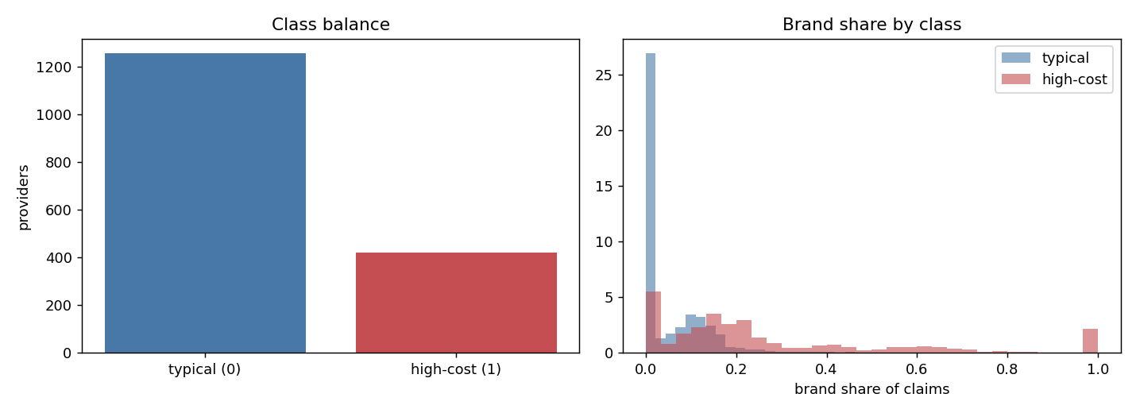
Figure 3. Left: 3 of 4 providers are 'typical' — the baseline to beat is 75%. Right: brand share already separates the classes, imperfectly.

4. Results
Trained on 80% of providers, evaluated on the held-out 20% (stratified split; scaler fit on training data only):
- Accuracy 84.8% against the 74.9% always-say-typical baseline.
- ROC AUC 0.879 — strong ranking quality for a model that never saw a dollar figure.
- Error pattern: most mistakes are high-cost prescribers missed at the 0.5 threshold; a screening application would lower the threshold to catch more, accepting more false alarms.
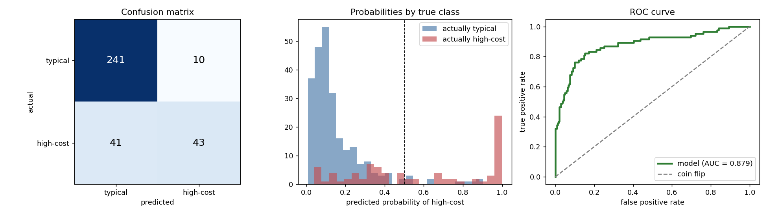
Figure 4. Confusion matrix; predicted probabilities by true class; ROC curve versus the coin-flip diagonal.

5. Part 2 — Odds and log(odds)
Probability is not the only language for chance. The odds are p / (1 − p): p = 0.75 means odds of 3 ('3 to 1'). Odds are asymmetric — 'against' outcomes squeeze into (0, 1) while 'for' outcomes stretch to infinity — and taking the logarithm restores symmetry.
The payoff is the bridge back to what you already know. Rearranging the sigmoid: log(p / (1 − p)) = b0 + b1x1 + … + bnxn. Logistic regression IS linear regression — on the log(odds) scale. Every coefficient bi is the change in log(odds) per one-unit increase in xi, all else held fixed.
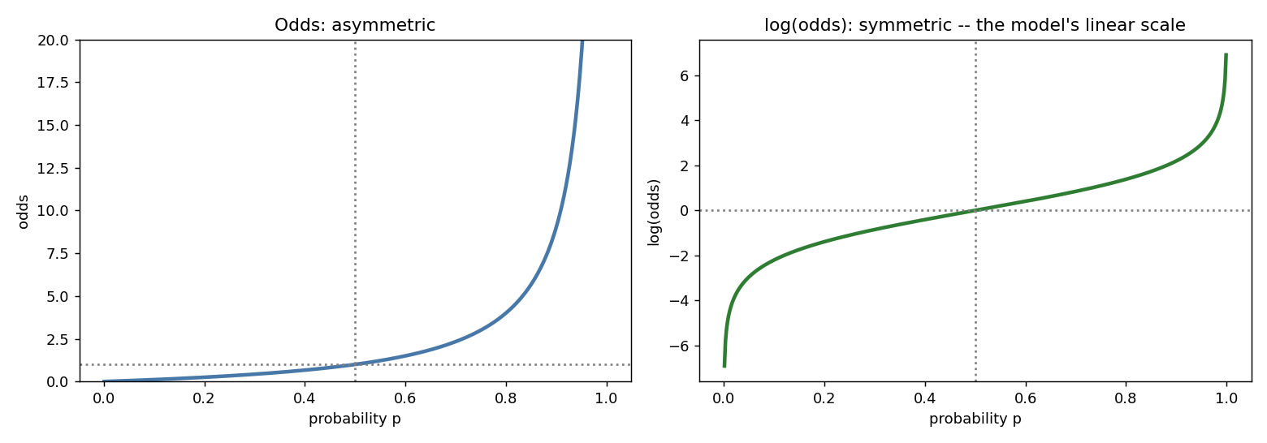
Figure 5. Odds are asymmetric in p; log(odds) are symmetric around p = 0.5 — the scale on which the model is linear.
From our training data: p(high-cost) = 0.250, so odds = 0.334 ('1 to 3 against') and log(odds) = −1.10.

6. Coefficients, log(odds ratios), and Odds Ratios
Because features were standardized, each coefficient answers: if this feature rises by one standard deviation, how much does the log(odds) of high-cost change? Exponentiating converts it to an odds ratio (OR = e^b): the multiplier applied to the odds. OR = 1 means no effect; OR = 2 doubles the odds; OR = 0.5 halves them. The coefficient itself is the log(odds ratio) — the same information on the additive scale.
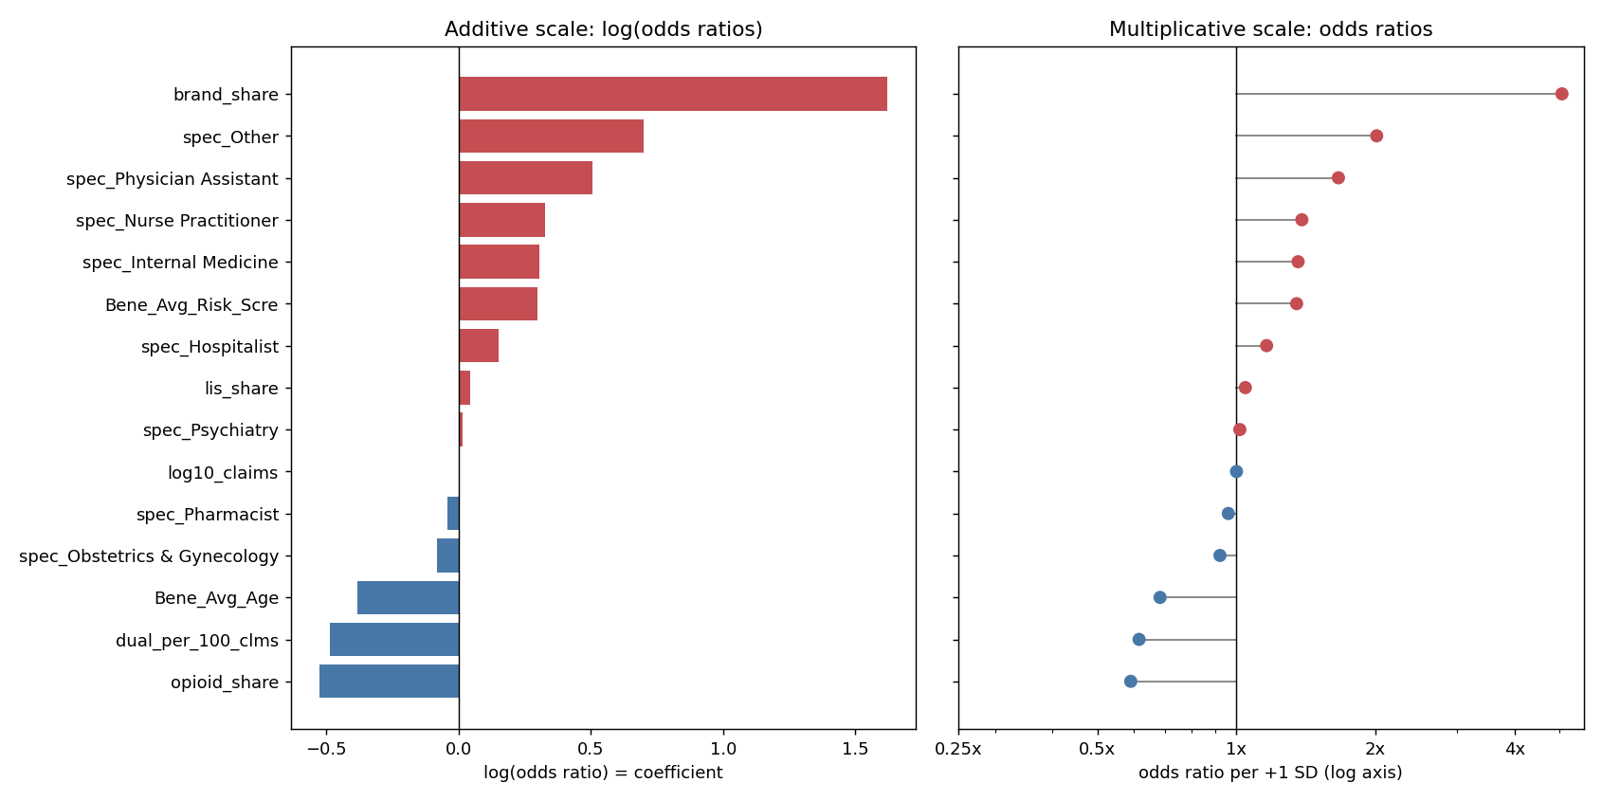
Figure 6. The same model on two scales: coefficients (log odds ratios, symmetric around 0) and odds ratios (multiplicative, reference line at 1).
- Top driver — brand share: coefficient +1.62, odds ratio e^1.62 ≈ 5.1× per +1 SD. The model discovered on its own that brand-drug prescribing dominates cost per claim — exactly right for specialty pharmacy economics.
- Protective features: high opioid share and older panels point toward 'typical' — opioid-heavy pain practices prescribe many inexpensive generics.
- Reading dummies: each specialty's odds ratio is relative to the reference specialty left out of the encoding.

7. A Worked Example, End to End
For a provider average on everything else, moving only brand share (intercept −1.39, coefficient +1.62):
+0 SD: log-odds -1.39 | odds 0.25 | p(high-cost) 19.9%
+1 SD: log-odds +0.23 | odds 1.26 | p(high-cost) 55.8%
+2 SD: log-odds +1.85 | odds 6.38 | p(high-cost) 86.5%
Each step multiplies the odds by the same 5.06 — that is what 'linear in log(odds)' means — but the probability jumps unevenly (19.9% → 55.8% → 86.5%), because the sigmoid is steep near p = 0.5 and flat near the extremes:
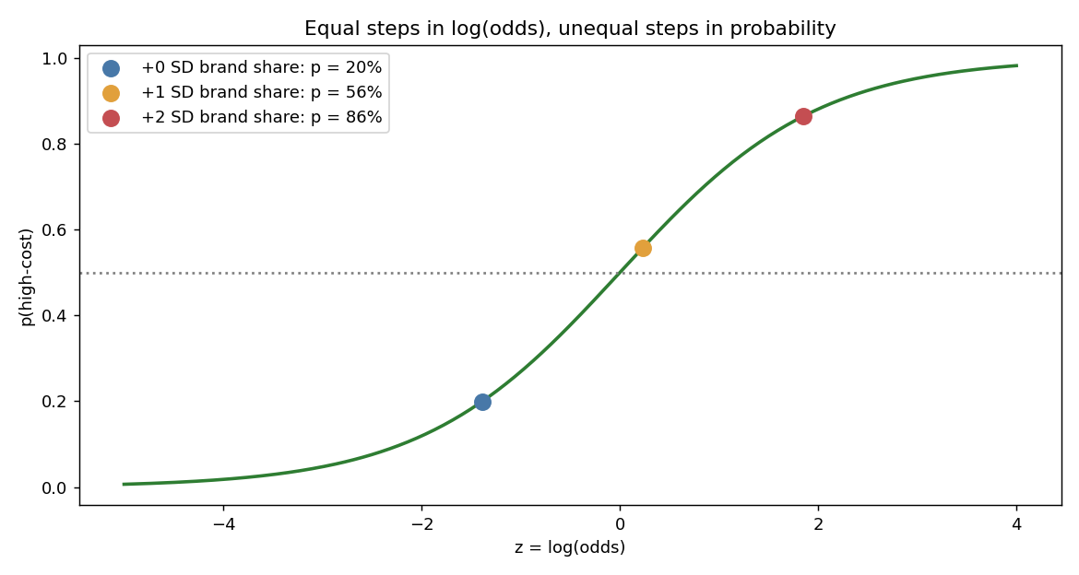
Figure 7. Equal steps in log(odds) are unequal steps in probability. This is why effects are reported as odds ratios, not percentage points.

8. Part 3 — Statistical Inference: the Log-Odds Line and Wald's Test
Parts 1–2 told us what the model learned; Part 3 asks whether we should believe it — could coefficients this size appear by chance in ~1,300 training providers?
First, the promise from Part 2 made visible. We bin providers by brand share, compute the observed fraction of high-cost providers per bin, and plot that fraction twice: as a probability, and transformed to log(odds). On the transformed axis the S-curve — data and model alike — becomes a straight line you can read exactly like a linear regression fit (intercept −1.97, slope +7.49 per unit of brand share):
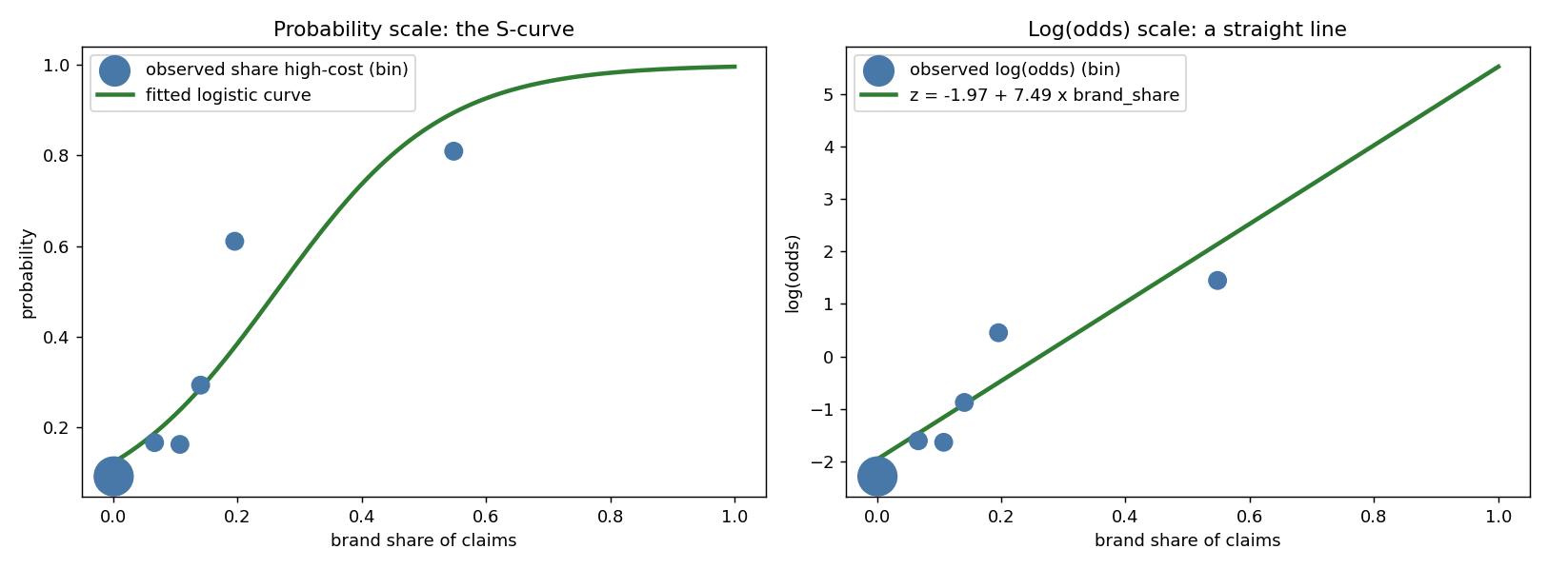
Figure 8. The same data and model on two y-axes: probability (S-curve) and log(odds) (straight line). Bubble size is providers per bin.
Second, the significance question. scikit-learn reports no standard errors, so we refit the identical model with statsmodels, which produces the full regression table: coefficient, standard error, z, p-value, and 95% confidence interval per feature (plus McFadden's pseudo-R², 0.31 here — strong for logistic regression). Wald's test asks, for each coefficient: if the true effect were zero (odds ratio = 1), how surprising is this estimate?
Wald statistic: z = coefficient / standard error, compared to the standard normal
brand_share: z = +1.653 / 0.141 = +11.8 -> p < 0.001
95% CI (log-odds): [+1.38, +1.93] -> odds ratio CI: [3.97x, 6.88x]
Since |z| > 1.96 the effect is significant at the 5% level; equivalently, the log-odds interval excludes 0 and the odds-ratio interval excludes 1 — all three statements are the same fact. Applying the test to every feature (filled markers significant, hollow not):
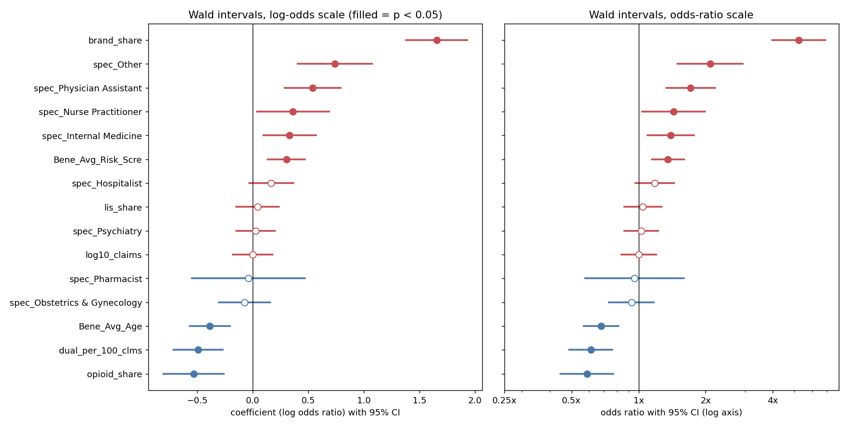
Figure 9. Wald 95% confidence intervals for every coefficient, on the log-odds scale (reference 0) and odds-ratio scale (reference 1). Nine of fifteen features are significant at p < 0.05.
Where does the t-test you know from linear regression fit in? It has the identical structure — estimate divided by its standard error — but linear regression must also estimate the residual variance, which is what produces the heavier-tailed t-distribution. Logistic regression has no separate residual variance (Bernoulli variance is determined by p itself), so the Wald statistic is compared to the standard normal: a z-test. The classic two-sample t-test still earns its keep in exploration before modeling: mean brand share differs between high-cost and typical prescribers (Welch t = 15.9, p < 0.001). The t-test says the group means differ; Wald's test answers the multivariable version — brand share predicts high-cost even with specialty, panel age, and risk score held fixed.

9. Pitfalls to Avoid
- Data leakage: never let the label's ingredients (here, drug cost) into the features, and never fit scalers on the test set.
- Trusting accuracy alone: with 75% of providers 'typical', 75% accuracy is free. Compare to the baseline and check ROC AUC.
- The 0.5 threshold is not sacred: tune it to your costs — outreach screening tolerates false alarms; auditing may not.
- Odds ratios are associations: a 4.5× odds ratio for brand share does not prove brand prescribing causes high cost per claim.
- Sample honesty: an integer DATA_ROWS gives the FIRST N providers by NPI, which is not a random sample — setting DATA_ROWS to “full” removes that caveat; suppressed counts were zero-filled, and CMS refreshes the data annually. Every p-value inherits these caveats.
- Wald's weakness: with small samples, separation, or huge coefficients the Wald test misbehaves — the standard error can grow faster than the coefficient, making a strong effect look insignificant. The likelihood-ratio test is the robust alternative, and Firth's penalized likelihood is the standard remedy when separated categories must be kept rather than merged.
- Always check “converged: True”: in the statsmodels header before reading any p-value. Without the separation guard this same model reports converged: False, an intercept standard error near 394,000, and a confidence interval of ±771,000 — numerically produced, entirely meaningless.

Project Files
- “30 logistic_regression_pharmacy.py” — runnable script; prints all results and saves every figure to ./charts/.
- “40 logistic_regression_pharmacy.ipynb” — the full interactive tutorial (Parts 1 and 2) with outputs and graphs included.
- “60 logistic_regression_pharmacy_fabric.ipynb” — Microsoft Fabric-ready version (see “50 Fabric Setup Guide”).
- No data file is included or needed — every script and notebook downloads from data.cms.gov at run time.

Dataset Source
- Name: Medicare Part D Prescribers — by Provider (2024 data year).
- Publisher: Centers for Medicare & Medicaid Services (CMS); public U.S. Government work, refreshed annually.
- Access: data.cms.gov public data API, no key required: data.cms.gov/provider-summary-by-type-of-service/medicare-part-d-prescribers/medicare-part-d-prescribers-by-provider
- Size: 1,416,883 providers in the full release; the code pulls any number of them, or all of them, at run time.
- Two access routes, both public and key-free: the JSON data API (fast for the first N providers) and the bulk CSV (the practical way to move the whole population, streamed in chunks).

